O‘ZBEKISTON RESPUBLIKASI OLIY TA’LIM, FAN VA
INNOVATSIYALAR VAZIRLIGI


Farg‘ona davlat universiteti akademik litseyi

Ingliz tilida

Til ko‘nikmalari integratsiyasi fanidan

o‘quv-uslubiy ko‘rsatmasi

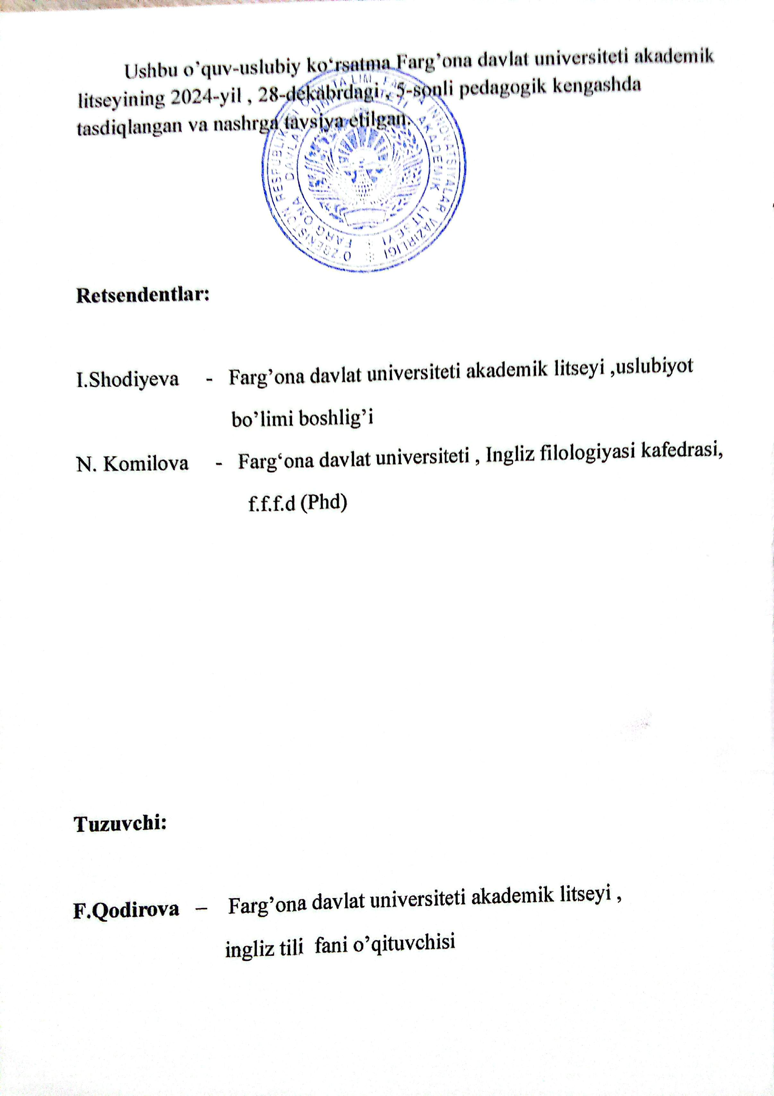
1. Theme : National symbols and government structure of

Uzbekistan.

The Republic of Uzbekistan has its own state symbols - the flag, the emblem, and the anthem sanctioned by law. The Constitution of the Republic of Uzbekistan. Article 5.
THE STATE FLAG OF THE REPUBLIC OF UZBEKISTAN

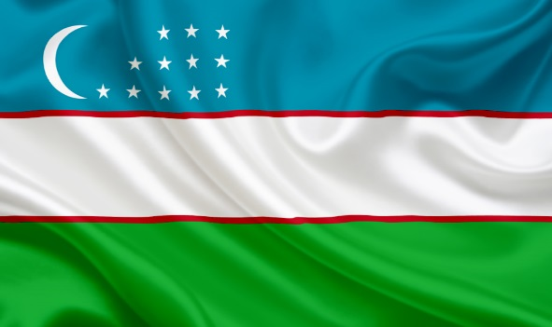

The law about "The State Flag of the Republic of Uzbekistan" was adopted on November 18 in 1991 in the 8th session of the Supreme Council of Uzbekistan.
The flag of our country is a symbol of the sovereignty of the Republic. The national flag of the Republic represents the country internationally when official delegations from Uzbekistan visit foreign countries, as well as at conferences, world exhibition, and sports competitions.
The national flag of the Republic is a right-angled colored cloth of three horizontal stripes: blue, white and green.
Blue is the symbol of the sky and water, which are the main source of life. Mainly, blue was the color of the state flag of Temur.
White is the traditional symbol of peace and good luck, as Uzbek people say "Ok yul".
Green is the color of nature and new life and good harvest.
Two thin red stripes symbolize the power of life.
There is a new moon, which symbolizes the newly independent Republic.
There are twelve stars, which stand for spiritual sign. The stars also signify the historical traditions of the Uzbek people, as well as ancient solar calendar. A particular attention to twelve stars in the flag is explained yet by another suggestion, that in the states previously existed in the territory of modern Uzbekistan the scientific thought as "Astrology" had seen its rise. The stars in the Uzbek flag also point to the ancient roots of local culture, the aspirations of Uzbek people towards perfection and loyalty.
THE STATE EMBLEM


The law about "The State Emblem" was approved by the 10-th session of the Supreme Council of the Republic of Uzbekistan on July 2, 1992.
The new state emblem of the Republic of Uzbekistan was created to reflect the many centuries of experience of the Uzbek people.
The state emblem of the Republic presents the image of the rising sun over a flourishing valley. Two rivers run through the valley, representing the Syrdarya and Amudarya. The emblem is bordered by wheat on the right side and branches of cotton with opened cotton bolls on the left side.
The eight-angle star is at the top of the emblem, symbolizing the unity and confirmation of the republic. The crescent and star inside the eight-pointed star are the sacred symbols of Islam. The mythical bird Semurg with outstretched wings is placed in the center of the emblem as the symbol of the national Renaissance. The entire composition aims to express to desire of the Uzbek people for peace, happiness and prosperity. At the bottom of the emblem inscribed the word "Uzbekistan" written in Uzbek on a ribbon in the national colors of the flag.

NATIONAL ANTHEM

The law "On national anthem of the Republic of Uzbekistan" was adopted on the December 10, 1992 at the 11th session of the Supreme Council of Uzbekistan.
Poem by A. Aripov
Music by M. Burkhanov
My country, sunny and free, salvation to your people,
You are a warmhearted companion to the friends
Flourish eternally with knowledge and invention,
May your fame shine as long as the world exists!
Refrain:
These golden valleys-dear Uzbekistan,
Manly spirit of ancestors is companion to you!
When the great power of people became exuberant
You are the country that amazes the world!
Belief of generous Uzbek does not die out,
Free, young children are a strong wing for you!
The torch of independence, guardian of peace,
Just motherland be eternally prosperous!
Refrain:
These golden valleys-dear Uzbekistan,
Manly spirit of ancestors is companion to you!
When the great power of people became exuberant
You are the country that amazes the world!

2. Theme : National symbols and government structure of English speaking countries.
Just like other countries around the world, many English speaking countries have their own national symbols. These symbols continue to be of great importance, even today. In this article, we will take a look at three countries where English is the native language: England, Scotland, and the United States. We will talk about the national symbols for each of these countries, their origins, what they mean, and more. Knowing these symbols can (sometimes) make it simpler to better understand the histories and people living in these countries.

The Symbols of England

Saint George’s Cross is probably the most recognized national symbol of England. This simple red colored cross on a white background has been the official flag of England for hundreds of years. Red roses are considered the national flower of England. Just like in Scotland (see below) the lion is an important symbol in England. They have often been used to symbolise bravery, and are depicted on flags, in statues, and more, across the nation. They were sometimes used on shields, as well. Because of its apparent strength and ability to endure, the oak is the tree of England.

Scotland’s Symbols
Scotland has a variety of national symbols. One of the most recognized is that of the Royal Arms of Scotland, which is represented by a lion. This is a red lion with blue claws and tongue on a yellow background. Today, you can see this symbol used by lots of sports teams that call Scotland home. The thistle, a prickly purple flower that grows wild, is another important symbol in Scotland. This symbol comes from a Scottish story that says a Norse soldier once stepped onto one as his army tried to sneak up on the Scottish army. He yelled, and alerted the Scots to their approach!


National symbols of Wales
The Red Dragon (Welsh: Y Ddraig Goch) of Wales is a symbol of Wales that appears in "Cyfranc Lludd a Lleuelys", Historia Brittonum, Historia Regnum Britianniae, and the Welsh triads. According to legend, Vortigern (Welsh: Gwrtheyrn) King of the Celtic Britons from Powys is interrupted whilst attempting to build fort at Dinas Emrys. He is told by Merlin/Ambrosius (Welsh: Myrddin) to dig up two dragons beneath the castle. He discovers a red dragon representing the Celtic Britons (now Welsh) and a white dragon representing Anglo-Saxons (now English). Merlin/Ambrosius prophesies that the Celtic Britons will reclaim the island and push the Anglo-Saxons back to the sea.^{[9][10]} As an emblem, the red dragon has been used since the reign of Cadwaladr, King of Gwynedd from around 655AD and is present on the national flag of Wales, which became an official flag in 1959

3. Theme : Social issues (Person and Personality)

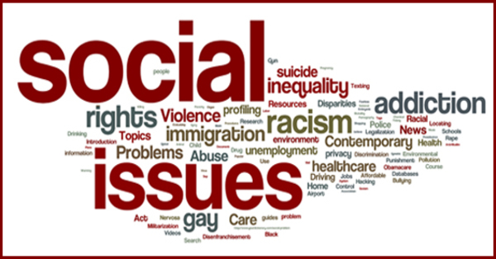

Social issue, a state of affairs that negatively affects the personal or social lives of individuals or the well-being of communities or larger groups within a society and about which there is usually public disagreement as to its nature, causes, or solution. The term social issue is frequently used synonymously with social problem.
Early uses of the term social problem are found in the writings of 19th- century intellectuals, including John Stuart Mill, the British philosopher who coined the phrase. For decades, “the” social problem—defined generally as that of resolving social conflict and creating a better society—was a common subject of debate, scholarship, and journalism in European and American literary culture. The idea of multiple social problems arose toward the end of the 19th century, as sociologists, social workers, and social reformers tended to frame their work in terms of the narrative of studying and solving society’s problems.
Since the late 20th century, the increased colloquial use of issue as a synonym for problem has led social issue to become a common synonym for social problem. While in some contexts issue has connotations that distinguish it from problem, within sociology and related fields the two terms are effectively synonymous. In everyday speech, social issue is occasionally used distinctly from social problem to identify a general topic of public discussion or debate.
While the basic definition of social issue as a problem facing a society is agreed upon, there is no uniform methodology to differentiate social issues from other problems that may less directly impact the well-being of individuals and communities, such as economic, environmental, ethical, legal, or political problems. Labeling these conditions “social issues” has more to do with the subjective perspective of the speaker—as well as the speaker’s purpose in addressing a certain audience, such as students, activists, or other professionals—than with the contours of the issue itself. For example, both an economist and a sociologist may write about the problem of unemployment; the economist might be primarily concerned with the technical factors that increase unemployment, while the sociologist might be concerned with the consequences of high unemployment in some communities or with the question of why the unemployment rate is greater in some communities than it is in others.
The causes of social issues are multifaceted, and many issues lack a source agreed upon by a consensus of experts. Some social issues may be framed as “bottom-up” or “top-down” problems. Drug addiction and alcoholism are exemplars of “bottom-up” social issues: individual people all over the world become addicted to various substances, and this personal problem influences their own lives as well as the lives of their loved ones. When the personal circumstance of addiction is multiplied to include large groups within a society, addiction becomes a social issue. In contrast, a “top-down” social issue is climate change. The causes of climate change cannot be traced back to the personal actions of a single individual, and they stem from a large number of individual agents and factors, but climate change has negatively affected communities throughout the world, including by increasing the likelihood of catastrophic flooding and drought.
A partial list of common, generally agreed-upon social issues might include, in addition to those mentioned above, the following problems: child abuse, civil rights, crime, criminal justice, disability rights, domestic violence, gambling, hate crime, health care (see medicine), homelessness, immigration, mental illness, obesity, police brutality and corruption, pollution, and poverty.

4. Theme : Food .



Food is any substance consumed by an organism for nutritional support. Food is usually of plant, animal, or fungal origin and contains essential nutrients such as carbohydrates, fats, proteins, vitamins, or minerals. The substance is ingested by an organism and assimilated by the organism's cells to provide energy, maintain life, or stimulate growth. Different species of animals have different feeding behaviours that satisfy the needs of their metabolisms and have evolved to fill a specific ecological niche within specific geographical contexts.
Omnivorous humans are highly adaptable and have adapted to obtain food in many different ecosystems. Humans generally use cooking to prepare food for consumption. The majority of the food energy required is supplied by the industrial food industry, which produces food through intensive agriculture and distributes it through complex food processing and food distribution systems. This system of conventional agriculture relies heavily on fossil fuels, which means that the food and agricultural systems are one of the major contributors to climate change, accounting for as much as 37% of total greenhouse gas emissions.
The food system has significant impacts on a wide range of other social and political issues, including sustainability, biological diversity, economics, population growth, water supply, and food security. Food safety and security are monitored by international agencies like the International Association for Food Protection, the World Resources Institute, the World Food Programme, the Food and Agriculture Organization, and the International Food Information Council.
Food is any substance consumed to provide nutritional support and energy to an organism. It can be raw, processed, or formulated and is consumed orally by animals for growth, health, or pleasure. Food is mainly composed of water, lipids, proteins, and carbohydrates. Minerals (e.g., salts) and organic substances (e.g., vitamins) can also be found in food. Plants, algae, and some microorganisms use photosynthesis to make some of their own nutrients. Water is found in many foods and has been defined as a food by itself. Water and fiber have low energy densities, or calories, while fat is the most energy-dense component. Some inorganic (non-food) elements are also essential for plant and animal functioning.
Human food can be classified in various ways, either by related content or by how it is processed. The number and composition of food groups can vary. Most systems include four basic groups that describe their origin and relative nutritional function: Vegetables and Fruit, Cereals and Bread, Dairy, and Meat. Studies that look into diet quality group food into whole grains/cereals, refined grains/cereals, vegetables, fruits, nuts, legumes, eggs, dairy products, fish, red meat, processed meat, and sugar-sweetened beverages. The Food and Agriculture Organization and World Health Organization use a system with nineteen food classifications: cereals, roots, pulses and nuts, milk, eggs, fish and shellfish, meat, insects, vegetables, fruits, fats and oils, sweets and sugars, spices and condiments, beverages, foods for nutritional uses, food additives, composite dishes and savoury snacks.
In a given ecosystem, food forms a web of interlocking chains with primary producers at the bottom and apex predators at the top. Other aspects of the web include detrovores (that eat detritis) and decomposers (that break down dead organisms). Primary producers include algae, plants, bacteria and protists that acquire their energy from sunlight. Primary consumers are the herbivores that consume the plants, and secondary consumers are the carnivores that consume those herbivores. Some organisms, including most mammals and birds, diet consists of both animals and plants,and they are considered omnivores. The chain ends with the apex predators, the
animals that have no known predators in its ecosystem. Humans are considered apex predators.
Humans are omnivores, finding sustenance in vegetables, fruits, cooked meat, milk, eggs, mushrooms and seaweed. Cereal grain is a staple food that provides more food energy worldwide than any other type of crop. Corn (maize), wheat, and rice account for 87% of all grain production worldwide. Just over half of the world's crops are used to feed humans (55 percent), with 36 percent grown as animal feed and 9 percent for biofuels. Fungi and bacteria are also used in the preparation of fermented foods like bread, wine, cheese and yogurt.
Plants as a food source are divided into seeds, fruits, vegetables, legumes, grains and nuts. Where plants fall within these categories can vary, with botanically described fruits such as the tomato, squash, pepper and eggplant or seeds like peas commonly considered vegetables. Food is a fruit if the part eaten is derived from the reproductive tissue, so seeds, nuts and grains are technically fruit. From a culinary perspective, fruits are generally considered the remains of botanically described fruits after grains, nuts, seeds and fruits used as vegetables are removed. Grains can be defined as seeds that humans eat or harvest, with cereal grains (oats, wheat, rice, corn, barley, rye, sorghum and millet) belonging to the Poaceae (grass) family and pulses coming from the Fabaceae (legume) family.
Fleshy fruits (grain, seeds and nuts) can be further classified as stone fruits (cherries and peaches), pome fruits (apples, pears), berries (blackberry, strawberry) , citrus (oranges, lemon), melons (watermelon, cantaloupe), Mediterranean fruits (grapes, fig), tropical fruits (banana, pineapple). Vegetables refer to any other part of the plant that can be eaten, including roots, stems, leaves, flowers, bark or the entire plant itself. These include root vegetables (potatoes and carrots), bulbs (onion family), flowers
(cauliflower and broccoli), leaf vegetables (spinach and lettuce) and stem vegetables (celery and asparagus).
5. Theme : Health problems.

Top 10 Most Common Health Issues
- 1.Physical Activity and Nutrition
- 2.Overweight and Obesity
- 3.Tobacco
- 4.Substance Abuse
- 5.HIV/AIDS
- 6.Mental Health
- 7.Injury and Violence
- 8.Environmental Quality
- 9.Immunization
10.Access to Health Care

Physical Activity and Nutrition
Research indicates that staying physically active can help prevent or delay certain diseases, including some cancers, heart disease and diabetes, and also relieve depression and improve mood. Inactivity often accompanies advancing age, but it doesn't have to. Check with your local churches or synagogues, senior centers, and shopping malls for exercise and walking programs. Like exercise, your eating habits are often not good if you live and eat alone. It's important for successful aging to eat foods rich in nutrients and avoid the empty calories in candy and sweets.

Overweight and Obesity
Being overweight or obese increases your chances of dying from hypertension, type 2 diabetes, coronary heart disease, stroke, gallbladder disease, osteoarthritis, sleep apnea, respiratory problems, dyslipidemia and endometrial, breast, prostate, and colon cancers. In-depth guides and practical advice about obesity are available from the National Heart Lung and Blood Institute of the National Institutes of Health.

Tobacco
Tobacco is the single greatest preventable cause of illness and premature death in the U.S. Tobacco use is now called "Tobacco dependence disease." The Centers for Disease Control and Prevention (CDC) says that smokers who try to quit are more successful when they have the support of their physician.

Substance Abuse
Substance abuse usually means drugs and alcohol. These are two areas we don't often associate with seniors, but seniors, like young people, may self-medicate using legal and illegal drugs and alcohol, which can lead to serious health consequences. In addition, seniors may deliberately or unknowingly mix medications and use alcohol. Because of our stereotypes about senior citizens, many medical people fail to ask seniors about possible substance abuse.

HIV/AIDS
Between 11 and 15% of U.S. AIDS cases occur in seniors over age 50. Between 1991 and 1996, AIDS in adults over 50 rose more than twice as fast as in younger adults. Seniors are unlikely to use condoms, have immune systems that naturally weaken with age, and HIV symptoms (fatigue, weight loss, dementia, skin rashes, swollen lymph nodes) are similar to symptoms that can accompany old age. Again, stereotypes about aging in terms of sexual activity and drug use keep this problem largely unrecognized. That's why seniors are not well represented in research, clinical drug trials, prevention programs and efforts at intervention.

Mental Health
Dementia is not part of aging. Dementia can be caused by disease, reactions to medications, vision and hearing problems, infections, nutritional imbalances, diabetes, and renal failure. There are many forms of dementia (including Alzheimer's Disease) and some can be temporary. With accurate diagnosis comes management and help. The most common late-in-life mental health condition is depression. If left untreated, depression in the elderly can lead to suicide. Here's a surprising fact: The rate of suicide is higher for elderly white men than for any other age group, including adolescents.

Injury and Violence
Among seniors, falls are the leading cause of injuries, hospital admissions for trauma, and deaths due to injury. One in every three seniors (age 65 and older) will fall each year. Strategies to reduce injury include exercises to improve balance and strength and medication review. Home modifications can help reduce injury. Home security is needed to prevent intrusion. Home-based fire prevention devices should be in place and easy to use. People aged 65 and older are twice as likely to die in a home fire as the general population.

Environmental Quality
Even though pollution affects all of us, government studies have indicated that low-income, racial and ethnic minorities are more likely to live in areas where they face environmental risks. Compared to the general population, a higher proportion of elderly are living just over the poverty threshold.

Immunization
Influenza and pneumonia and are among the top 10 causes of death for older adults. Emphasis on Influenza vaccination for seniors has helped. Pneumonia remains one of the most serious infections, especially among women and the very old.

Access to Health Care
Seniors frequently don't monitor their health as seriously as they should. While a shortage of geriatricians has been noted nationwide, URMC has one of the largest groups of geriatricians and geriatric specialists of any medical community in the country. Your access to health care is as close as URMC, offering a menu of services at several hospital settings, including the VA Hospital in Canandaigua, in senior housing, and in your community.

6. Theme : Family values.


Family values, sometimes referred to as familial values, are traditional or cultural values that pertain to the family's structure, function, roles, beliefs, attitudes, and ideals. Additionally, the concept of family values may be understood as a reflection of the degree to which familial relationships are valued within an individual's life.
Several online dictionaries define "family values" as the following:
- "the moral and ethical principles traditionally upheld and passed on within a family, as fidelity, honesty, truth, and faith."^{[1]}
- "values especially of a traditional or conservative kind which are held to promote the sound functioning of the family and to strengthen the fabric of society."^{[2]}
- "values held to be traditionally taught or reinforced within a family, such as those of high moral standards and discipline."
Life begins at home and home is where the heart of the family dwells. Family is the essence that helps define our very identity. We learn our most important life lessons from living in a family and learning family values.
Every family has family values, but they may not be positive, uplifting, or life-affirming. With God’s grace we can change our personal family values to practice new ways of thinking and acting that will change our lives. And we can teach them to our children to build their self-esteem and self-value.
The Five Primary Family Values are: love, respect, honor, sharing, and forgiveness. These are universal principles which help people live in harmony with one another, not only in families, but in communities, nations, and in the world. They are moral and ethical guidelines for positive “family” living.
Love is the first value and most important. Love is a unifying force in relationships. It is the direct sense that all things work together for good, despite the appearances to the contrary. If we are deprived of love, we wither and die. Love is feeling our own self-worth and reaching out to others to provide comfort, harmony, caring, and compassion. In order to practice this first value of Love, we must be committed to always act lovingly, no matter the situation. We can choose to be kind to each other, to listen, to speak loving words, to help each other, and to be someone who is easy to love.
The second Primary Family Value is Respect. Respect is the symbol of harmony in human relationships. It means to have a high or special regard for someone. It also means to admire, appreciate, and approve of another. Self-respect is the ability to admire and approve of oneself and is the first step. Respecting the rights of others to be who they choose to be is the second. All choices of lifestyles are based on a personal inner connection with the Divine, which has created unlimited possibilities. We are to respect each other, no matter outward appearances. We are all beloved Children of God, no exceptions.
Honor is the third Primary Family Value. To honor all life is to honor yourself. Honor means to do everything we can to foster and nourish the life of each person. Honor is defined as “the recognition of the Divine within.” We can recognize the Divine within each person and treat that indwelling Spirit with kindness, respect, and love. We show honor by being respectful and loving to all our brothers and sisters, for we are all God’s children and related as one human family. We can also honor others by not judging, working together, creating peace, and not destroying or wasting. We can honor our Mother Earth as our home by taking good care of our environment.
The fourth Primary Family Value is Sharing. Sharing means “to give some of what you have to another; or to use and enjoy something with others.” We are born with an innate desire to share. Sharing makes life easier. We share all the time even if we are not aware of doing so. We are always sharing our energy with one another. Humans are social creatures, and we thrive on relationships. Sharing is a special way to express Love, Respect, and Honor, but we must remember to ask permission before we share.
Forgiveness is the fifth Primary Family Value. Forgiveness means “to give up resentment” and “to grant relief to another person for a harm done.” It also means you recognize and allow room for error or weakness in another and in yourself. Forgiveness also means accepting requests for forgiveness from others and then releasing. If we are capable of hurting someone, we are also capable of forgiving them.
Without forgiveness we would not be able to move into harmony and peace. All healing beings with forgiveness. Modern medicine now realizes the importance of the emotional mind in healing. If the emotional mind does not believe it deserves healing because of some wrong or hurt, the person will not heal.

7. Theme : Educational system in Uzbekistan.

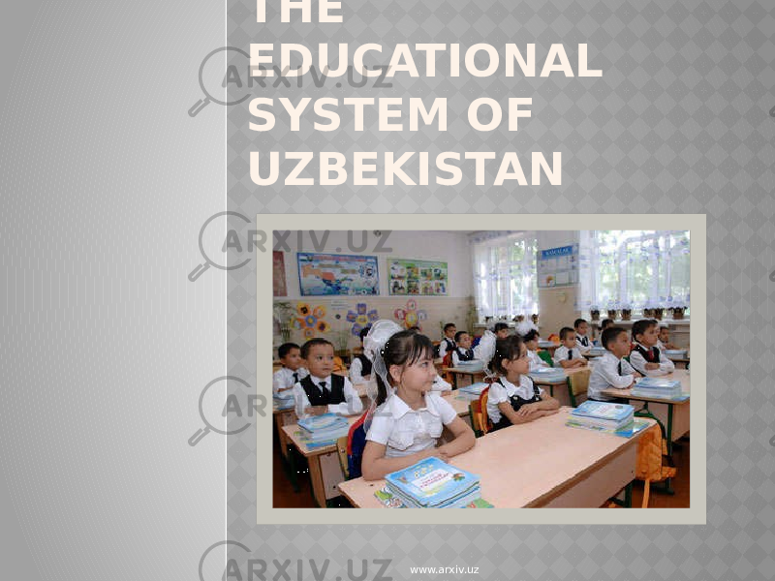
Education in Uzbekistan is generally managed by the Ministry of Kindergartens and Schools and Ministry of Higher Education, Science and Innovations with some other agencies and bodies responsible in certain areas as prescribed by the President of Uzbekistan.
The public compulsory school system is divided into three broad stages: primary (from Grade 1 to 5), secondary (from Grade 5 to 9) and upper or vocational (from Grade 10 to 11 or in lyceum, colleges, trade schools). Students are typically enrolled at the age of 7 and commonly end their secondary education at the age of 18, therefrom they either start their career or matriculate at a university.
Upper or vocational education is provided through a network of schools:
- Professional Technical School. Graduates receive a Junior Specialist Diploma equal to a Certificate of Complete Secondary Education.
- Technical College. Graduates receive a Junior Specialist Diploma equal to a Certificate of Complete Secondary Education.
- Lyceum or various training courses offered by higher education institutions or industry. Graduates receive a Junior Specialist Diploma or Diploma of Academic Lyceum equal to a Certificate of Complete Secondary Education.
In 2017, education reforms in Uzbekistan changed from 12-year program to 11 years after a previous reform disappointed and troubled parents and children. Eleven years of primary and secondary education are obligatory, starting at age seven. The rate of attendance in those grades is high, although the figure is significantly lower in rural areas than in urban centers. Preschool registration has decreased significantly since 1991.

Primary Education
In Uzbekistan 11 years of education are compulsory and free, beginning with 4 years at primary school, and followed by 2 phases of secondary education taking 5 and 2 years respectively. Primary school begins at age 6 and there is no specific leaving examination after the 4 years are complete.

Secondary Education
The next 5 years are spent at general secondary school from ages 10 to 15. Following that, there is a choice of between 2 to 3 years of upper education at either general or technical vocational schools. The former provides a certificate of completed secondary education and the opportunity to enter university, the latter a diploma of specialized secondary education, through a network of secondary vocational institutions.

Vocational Education
Unemployment remains relatively high, and there are many people desperately in need of new or more appropriate skills. There are a number of state and donor programs in place to address the structural training shortfall. Eventually, the goal is to meet European union standards.

8. Theme : Education system in English speaking countries.


Plenty of English speaking countries have a top-notch learning system. It often consists of a 3-tier system that includes primary, secondary and tertiary education.
Before children join the first tier, they are supposed to go through an early childhood level. Depending on the country, this may be referred to as nursery, elementary, kindergarten or preparatory stage. Let us look at the system in each of these countries.
The United Kingdom
In the UK, the education system is often divided into 4 main parts. These are primary, secondary, further and higher learning. It is compulsory for all children in the UK to attend primary as well as post-primary levels for a period of 5 years until a student gets to the age of 16.
Here the learning is usually split into key stages as follows:
- Level 1: For kids aged 5-7 years
- Level 2: For kids aged 7 to 11
- Level 3: For kids aged 11 to 14
- level 4: For kids aged 11 to 16
Level 1 and 2 usually consist of primary schools. When students reach 11 years, they can join post-primary schools and complete stage 3 and 4. Post-primary school often starts at age 11 until age 16. After completing secondary school, a learner can choose to proceed for further knowledge where they do their A-levels. This is a mandatory stage for all learners planning to join University.
Each level in the UK has different requirements that need to be met to get to the next stage. If you are searching for a recognized university, you can get in touch with the UK education department.
Canada
Education is necessary in Canada for students under 16. This applies to all provinces apart from New Brunswick where the compulsory age is 18. Most of the studying in Canada will continue until the 12th grade. The system is divided into elementary, intermediate, secondary and the post-secondary.
During their secondary and post-secondary education, students often opt to buy an essay in Canada to achieve good results at university.
Australia
Australia has a similar system but will little differences between territories and states. Primary and secondary is compulsory for students aged 6 to 16.
The system last for 13 years and consist of:
- Primary. Last 7 years from preparatory to 6 or7
- Secondary. Last for 3 or 4 years from 7or 8 to 8/10.
- Senior secondary. This usually run for a period of 2 years from 11 to 12
- Tertiary. This usually consists of a higher level such as universities and VET.
You can learn more about the system in Australia on the official education website.
The United States
Before joining higher learning, students in America are supposed to go through primary and secondary stages for a total of 12 years. Pupils start elementary classes at the age of 6.
Secondary education consists of two programs consisting of middle school and the junior middle school. The second part consists of high school. After a student graduate from this stage, they are awarded a diploma. You can learn more about the US education system here.

9. Theme : Relaxing and doing sport.
Intermediate control.
Relaxing things are soothing: they make you feel calm, happy, and at ease.
Relaxing things are the opposite of things that create worry or excitement. For a lot of people, watching TV and reading are relaxing. Jumping off a building or taking part in a high-speed chase isn't relaxing at all — neither is taking a test. If something makes you feel mellow, then it's probably relaxing. It helps most people sleep if they do relaxing things first.


A human activity involving physical exertion and skill as the primary focus of the activity, with elements of competition or social participation where rules and patterns of behaviour governing the activity exist formally through organisations and is generally recognised as a sport.
Sometimes, the desire to exercise isn't always there. And even though as summer approaches, we always tell ourselves that this year will finally be the one to get back into it, it can be hard to leave the comfort of home to go train. Yet, even with minimal effort, exercise can greatly improve your quality of life in many ways.
The following 9 reasons should provide you with the necessary motivation to get back into the groove !
- 1. Being healthy!
- 2. Sport for beautiful skin.
- 3. Sport protects your brain.
- 4. Control or lose weight.
- 5. Boost your energy level.
- 6. Muscle gain.
- 7. Better sleep quality!
- 8. Improve your intimate life.
- 9. A fulfilling pregnancy.

Intermediate control.
Choose one of the ticket with questions and answer them.
What is the national symbol of Uzbekistan?
What is the most famous national symbol?
What is the national flag of Uzbekistan?
What is the symbol of the English speaking country?
What is the national symbol of Scotland?
What are the symbols of the English culture?
What are the symbols of the Wales?
What is your social personality?
What is a food chain simple answer?
What are 5 food chain examples?
What is a simple food chain?
What are some health problems?
What are the 3 biggest health problems?
What is health problems and definition?
What are physical health problems?
What is the education system in Uzbekistan?
What are the problems of education in Uzbekistan?
What is the grade system in Uzbekistan?
What countries speak English in schools?
Which country has the best education system in the world?
What are the systems in education?
What is the best education system?
Why is doing sport a good way to relax?
What is a relaxing sport?
What are the benefits of relaxation in sport?
How to relax when playing sports?

10. Theme : Communication and technology

Communication is commonly defined as the transmission of information. Its precise definition is disputed and there are disagreements about whether unintentional or failed transmissions are included and whether communication not only transmits meaning but also creates it. Models of communication are simplified overviews of its main components and their interactions. Many models include the idea that a source uses a coding system to express information in the form of a message. The message is sent through a channel to a receiver who has to decode it to understand it. The main field of inquiry investigating communication is called communication studies.
A common way to classify communication is by whether information is exchanged between humans, members of other species, or non-living entities such as computers. For human communication, a central contrast is between verbal and non-verbal communication. Verbal communication involves the exchange of messages in linguistic form, including spoken and written messages as well as sign language. Non-verbal communication happens without the use of a linguistic system, for example, using body language, touch, and facial expressions. Another distinction is between interpersonal communication, which happens between distinct persons, and intrapersonal communication, which is communication with oneself. Communicative competence is the ability to communicate well and applies to the skills of formulating messages and understanding them.
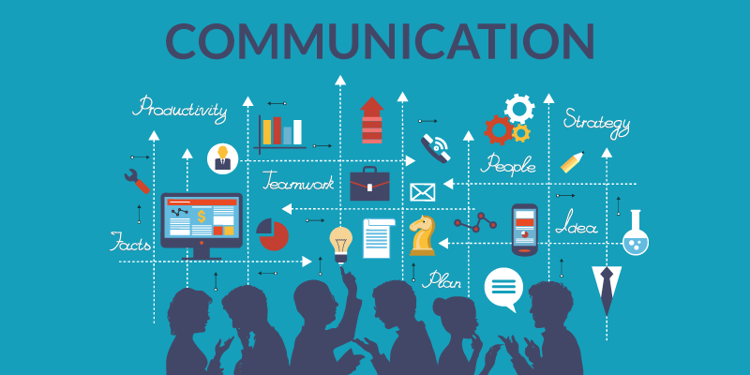
Technology is the application of conceptual knowledge to achieve practical goals, especially in a reproducible way.^{[1]} The word technology can also mean the products resulting from such efforts,^{[2][3]} including both tangible tools such as utensils or machines, and intangible ones such as software. Technology plays a critical role in science, engineering, and everyday life.
Technological advancements have led to significant changes in society. The earliest known technology is the stone tool, used during prehistory, followed by the control of fire—which in turn contributed to the growth of the human brain and the development of language during the Ice Age, according to the cooking hypothesis. The invention of the wheel in the Bronze Age allowed greater travel and the creation of more complex machines. More recent technological inventions, including the printing press, telephone, and the Internet, have lowered barriers to communication and ushered in the knowledge economy.

11. Theme : Environmental protection.
Environmental protection, or environment protection, is the practice of protecting the natural environment by individuals, groups and governments.^{[1]} Its objectives are to conserve natural resources and the existing natural environment and, where it is possible, to repair damage and reverse trends.^{[2]}
Due to the pressures of overconsumption, population growth and technology, the biophysical environment is being degraded, sometimes permanently. This has been recognized, and governments have begun placing restraints on activities that cause environmental degradation. Since the 1960s, environmental movements have created more awareness of the multiple environmental problems. There is disagreement on the extent of the environmental impact of human activity, so protection measures are occasionally debated.
Discussion concerning environmental protection often focuses on the role of government, legislation, and law enforcement. However, in its broadest sense, environmental protection may be seen to be the responsibility of all the people and not simply that of government. Decisions that impact the environment will ideally involve a broad range of stakeholders including industry, indigenous groups, environmental group and community representatives. Gradually, environmental decision-making processes are evolving to reflect this broad base of stakeholders and are becoming more collaborative in many countries
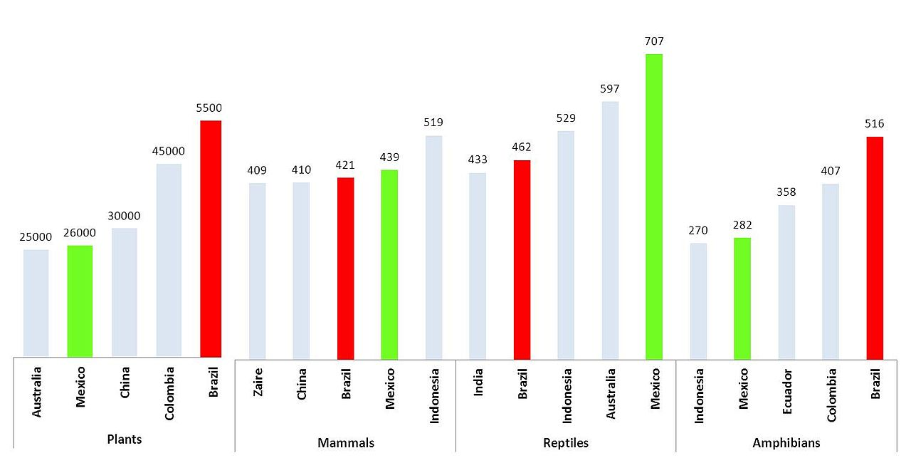

Top five countries by biological diversity.

12. Theme : Work and business.



Definition
- Work: Work refers to the tasks, duties, or activities performed by individuals in exchange for compensation. It typically involves labor or services provided by employees or freelancers to employers or clients.
- Business: Business involves the operation of an organization or enterprise with the primary goal of generating profit through the sale of goods or services. It encompasses activities such as production, marketing, sales, and finance.

Ownership
- Work: In work, individuals usually perform tasks for an employer or client without having ownership or equity in the organization. Employees are compensated through salaries, wages, or fees for services rendered.
- Business: In business, ownership may be held by individuals, partnerships, or corporations. Business owners have ownership rights and responsibilities over the assets, operations, and profits of the enterprise.

Income
- Work: Income in work is earned through salaries, wages, or fees paid by employers or clients for the services rendered. The amount of income is typically determined by factors such as job role, qualifications, and experience.
- Business: Income in business is generated through the sale of products or services to customers. Business owners earn profits from revenue after deducting expenses such as production costs, overheads, and taxes.

Business is the practice of making one's living or making money by producing or buying and selling products (such as goods and services). It is also "any activity or enterprise entered into for profit."
A business entity is not necessarily separate from the owner and the creditors can hold the owner liable for debts the business has acquired.^{[6]} The taxation system for businesses is different from that of the corporates. A business structure does not allow for corporate tax rates. The proprietor is personally taxed on all income from the business.
A distinction is made in law and public offices between the term business and a company such as a corporation or cooperative. Colloquially, the terms are used interchangeably.
Corporations are distinct from with sole proprietors and partnerships. They are separate legal entities and provide limited liability for their owners and members. They are subject to corporate tax rates. They are also more complicated and expensive to set up, but offer more protection and benefits for the owners and members.

13. Theme : Relationship management.

Relationship management is a strategy in which an organization maintains an ongoing level of engagement with its audience and supply chain. This management can occur between a business and its customers, which is called business to consumer [B2C], or between a business and other businesses, which is referred to as business to business [B2B].
Relationship management aims to create a partnership between an organization and its customers, instead of viewing the relationship as merely transactional. This is done through sales, service, and the analysis of data.

KEY TAKEAWAYS
- Relationship management is what an organization undertakes to establish and maintain engagement with its customers and business partners.
- Management can occur as business-to-customer or business-to-business.
- Relationship management can benefit from the use of data analytics and software.
- Companies often employ relationship managers to oversee their relationships.
- Relationship management can increase brand loyalty, spot inefficiencies, attract new customers and suppliers, and mitigate risk.

How Relationship Management Works
Businesses must establish and maintain good relationships with their business partners and their customers in order to succeed. This is done through relationship management. Relationship management involves strategies to build client support for a business and its offerings and increase brand loyalty. Building a relationship most often occurs at the customer level, but it is valuable between businesses as well.
Building a relationship with clients yields rewards for all parties. Customers who feel that a company is responsive to their needs likely will continue to use that company's products and services. The same principle applies to relationships between businesses. Put simply, business partners are more likely to be loyal when there's a better connection between the two.
A company's reputation for responsiveness and generous post-sales involvement can often stimulate new sales. Maintaining communication with consumers lets a company identify potential problems before they come to a costly head.
A business may hire a relationship manager to oversee relationship building or it may combine this function with another marketing or human resources (HR) role. The role of a relationship manager requires analytical and communication skills. Professionals in smaller firms may handle both consumer and business relations. Larger companies may employ two different individuals to handle each.
And having a good relationship may help increase payment times to them from, say, 30 to 45 days.

14. Theme : Cross-cultural communication.

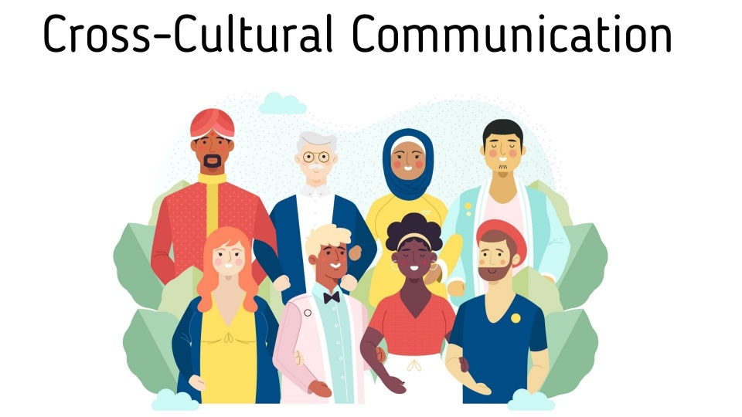
Cross-cultural communication is a field of study investigating how people from differing cultural backgrounds communicate, in similar and different ways among themselves, and how they endeavor to communicate across cultures. Intercultural communication is a related field of study.^{[1]}
Cross-cultural deals with the comparison of different cultures. In cross-cultural communication, differences are understood and acknowledged, and can bring about individual change, but not collective transformations. In cross-cultural societies, one culture is often considered “the norm” and all other cultures are compared or contrasted to the dominant culture.^{[2]}

Origins and culture
During the Cold War, the economy of the United States was largely self-contained because the world was polarized into two separate and competing powers: the East and the West. However, changes and advancements in economic relationships, political systems, and technological options began to break down old cultural barriers. Business transformed from individual-country capitalism to global capitalism. Thus, the study of cross-cultural communication was originally found within businesses and government, both seeking to expand globally. Businesses began to offer language training to their employees and programs were developed to train employees to understand how to act when abroad. With this also came the development of the Foreign Service Institute, or FSI, through the Foreign Service Act of 1946, where government employees received training and prepared for overseas posts.^{[3]} There began also implementation of a "world view" perspective in the curriculum of higher education.^{[4]} In 1974, the International Progress Organization, with the support of UNESCO and under the auspices of Senegalese President Léopold Sédar Senghor, held an international conference on "The Cultural Self-comprehension of Nations" (Innsbruck, Austria, 27–29 July 1974) which called upon United Nations member states "to organize systematic and global comparative research on the different cultures of the world" and "to make all possible efforts for a more intensive training of diplomats in the field of international cultural co-operation ... and to develop the cultural aspects of their foreign policy."
There has become an increasing pressure for universities across the world to incorporate intercultural and international understanding and knowledge into the education of their students.^{[6]} International literacy and cross-cultural understanding have become critical to a country's cultural, technological, economic, and political health. It has become essential for universities to educate, or more importantly, "transform", to function effectively and comfortably in a world characterized by close, multi-faceted relationships and permeable borders. Students must possess a certain level of global competence to understand the world they live in and how they fit into this world. This level of global competence starts at ground level- the university and its faculty- with how they generate and transmit cross-cultural knowledge and information to students.^{[7]}
Cross-cultural communication endeavors to bring together the relatively unrelated fields of cultural anthropology with established areas of communication. At its core, cross-cultural communication involves understanding the ways in which culturally distinct individuals communicate with each other. Its charge is to also produce some guidelines with which people from different cultures can better communicate with each other.

15. Theme : Mass-media and society.

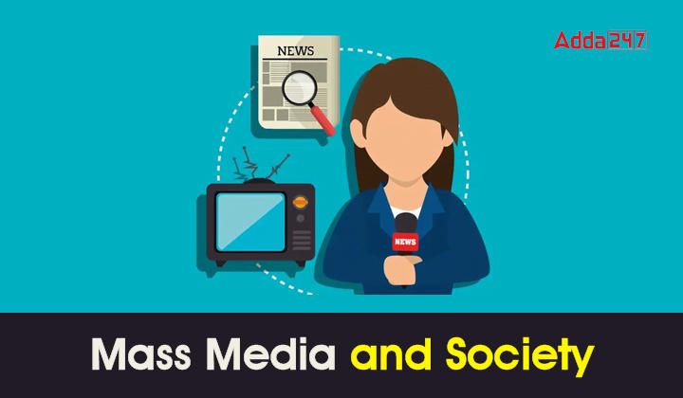

The mass media and its influence on large masses has increased exponentially during the last few decades. Mass Media has transformed into a powerful entity that shapes public perception, influences social media norms, and drives cultural evolution. With its massive reach, mass media affects various aspects of society from politics to lifestyle and entertainment. In this blog let’s delve into the profound impact of mass media on society, talking about both the positive as well as negative influences.

Mass media include the diverse arrays of media that reach a large audience via mass communication.
Broadcast media transmit information electronically via media such as films, radio, recorded music, or television. Digital media comprises both Internet and mobile mass communication. Internet media comprise such services as email, social media sites, websites, and Internet-based radio and television. Many other mass media outlets have an additional presence on the web, by such means as linking to or running TV ads online, or distributing QR codes in outdoor or print media to direct mobile users to a website. In this way, they can use the easy accessibility and outreach capabilities the Internet affords, as thereby easily broadcast information throughout many different regions of the world simultaneously and cost-efficiently. Outdoor media transmits information via such media as augmented reality (AR) advertising; billboards; blimps; flying billboards (signs in tow of airplanes); placards or kiosks placed inside and outside buses, commercial buildings, shops, sports stadiums, subway cars, or trains; signs; or skywriting.^{[1]} Print media transmit information via physical objects, such as books, comics, magazines, newspapers, or pamphlets.^{[2]} Event organising and public speaking can also be considered forms of mass media.
Mass media organisations or mass media companies that control these technologies include movie studios, publishing companies, and radio and television stations (the latter are also sometimes known as mass media networks); they often form media conglomerates.
In the late 20th century, mass media could be classified into eight mass media industries: books, the Internet, magazines, movies, newspapers, radio, recordings and television. The explosion of digital communication technology in the late 20th and early 21st centuries made prominent the question: what forms of media should be classified as "mass media"? For example, it is controversial whether to include mobile phones and video games in the definition. In the early 2000s, a classification called the "seven mass media" came into use. In order of introduction, they are:
- Print (books, pamphlets, newspapers, magazines, posters, etc.) from the late 15th century
- Recordings (gramophone records, magnetic tapes, cassettes, cartridges, CDs and DVDs) from the late 19th century
- Cinema from about 1900
- Radio from about 1910
- Television from about 1950
- The Internet from about 1990
- Mobile phones from about 2000
Each mass medium has its own content types, creative artists, technicians and business models. For example, the Internet includes blogs, podcasts, web sites and various other technologies built atop the general distribution network. The sixth and seventh media, Internet and mobile phones, are often referred to collectively as digital media; and the fourth and fifth, radio and TV, as broadcast media. Some argue that video games have developed into a distinct mass form of media.^{[7]}
While a telephone is a two-way communication device, mass media communicates to a large group. In addition, the telephone has transformed into a cell phone which is equipped with Internet access. A question arises whether this makes cell phones a mass medium or simply a device used to access a mass medium (the Internet).
Video games may also be evolving into a mass medium. Video games (for example, massively multiplayer online role-playing games (MMORPGs), such as RuneScape) provide a common gaming experience to millions of users across the globe and convey the same messages and ideologies to all their users. Users sometimes share the experience with one another by playing online. Excluding the Internet, however, it is questionable whether players of video games are sharing a common experience when they play the game individually. It is possible to discuss in great detail the events of a video game with a friend one has never played with, because the experience is identical to each. The question, then, is whether this is a form of mass communication.^{[citation needed]}
A society (/səˈsaɪəti/) is a group of individuals involved in persistent social interaction or a large social group sharing the same spatial or social territory, typically subject to the same political authority and dominant cultural expectations. Societies are characterized by patterns of relationships (social relations) between individuals who share a distinctive culture and institutions; a given society may be described as the sum total of such relationships among its constituent members.
Human social structures are complex and highly cooperative, featuring the specialization of labor via social roles. Societies construct roles and other patterns of behavior by deeming certain actions or concepts acceptable or unacceptable—these expectations around behavior within a given society are known as societal norms. So far as it is collaborative, a society can enable its members to benefit in ways that would otherwise be difficult on an individual basis.
Societies vary based on level of technology and type of economic activity. Larger societies with larger food surpluses often exhibit stratification or dominance patterns. Societies can have many different forms of government, various ways of understanding kinship, and different gender roles. Human behavior varies immensely between different societies; humans shape society, but society in turn shapes human beings.

16. Theme : Medicine and health.

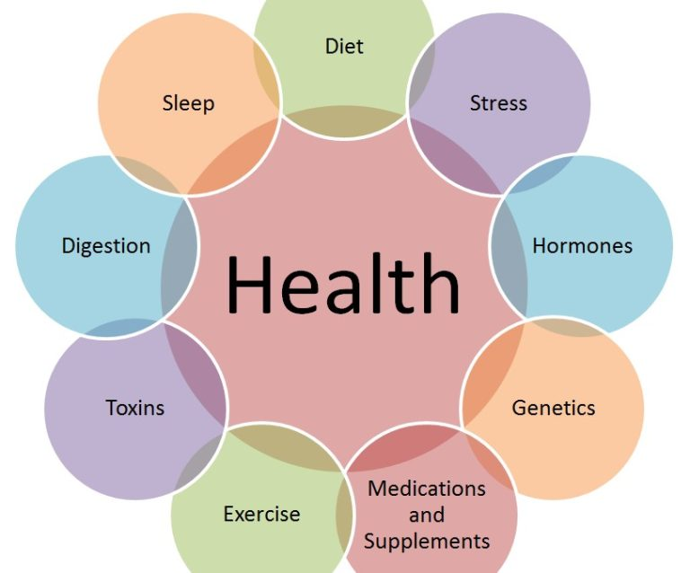
Medicine and Health encompasses the study of the prevention, cure, and understanding of disease as well as the investigation of physical and mental wellbeing. Oxford Reference provides more than 82,000 concise definitions and in-depth, specialist encyclopedic entries on the wide range of subjects within this discipline.
Written by trusted experts for researchers at every level, our coverage comprises authoritative, highly accessible information on the very latest terminology, theories, treatments, people, and organizations relating to all areas of medicine and health—from public health, psychology, sports science, and food and nutrition, to biomedicine, epidemiology, nursing, and plastic surgery.

17. Theme :City life or rural life?
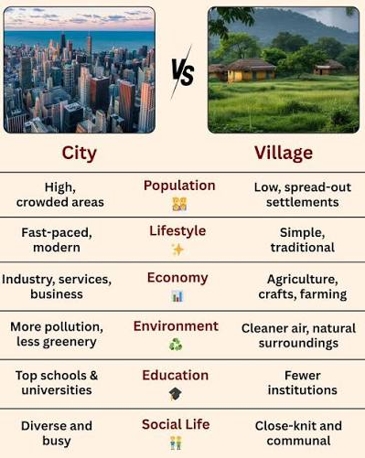

City life offers career growth, advanced healthcare, and modern conveniences, but comes with high costs and pollution. Rural life provides peace, fresh air, and lower costs, but has fewer jobs and limited public transport. The choice depends on what you value most.
City Life
- Jobs: More offices, trade, and company options.
- Schools: Better universities and training centers.
- Health: Advanced hospitals and medical specialists.
- Downside: High cost of living, noise, and air pollution.
Rural Life
- Nature: Clean air, open spaces, and quiet surroundings.
- Pace: A slower, less stressful daily routine.
- Cost: Cheaper housing and daily expenses.
- Downside: Fewer local businesses and fewer job options.

Village life reflects the rural lifestyle and city life shows the urban lifestyle. Life in both rural and urban areas has its own plus points and problems. One is quite different from each other. Traditionally, India is a predominantly rural country as Mahatma Gandhi had said, “The real India lives in villages”. Though India is mainly a land of villages, there are many cities as well in the country. Life in these big cities is quite different from life in a village. Let us consider, in brief, life in a big city and point out some of its important advantages and disadvantages.
In big cities, there are good arrangements for education. The big college even universities are available. There are also a very large number of school both government and private in the big city. These arrangements do not exist in small towns and villages.
Cities also provide sufficient medical facilities. Almost in every city, there are good hospitals in which the poor get free medicines and treatment. Many qualified doctors are also there to serve the sick and the suffering. Indeed lack of such medical arrangement is the main drawback of villages.
Cities also provide many opportunities for amusement and recreation. In every city, there are a number of cinema houses and multiplexes, where we can enjoy with family. Also, a number of restaurants and hotels are available for better food of variety. There are also many parks and gardens where we can enjoy the best natural beauty. Villages are always lacking such facilities.
The most important advantages of cities are the availability of huge opportunity for employment. They are centers of trade and commerce as well as offices of many multinational companies. Persons with different qualifications can easily find jobs to suit them. In villages, employment is available mostly in farming. Due to farming, only seasonal jobs are available to a large population in villages.
Cities are having a variety of people from various cultures. But real India and its customs are highly visible in villages.
It is fact villages are always natural due to be their self-creation by nature. On the other hand, most cities are manmade. Hence the natural environment of villages is their main attraction. In villages only we may have the charms of birds and flowers or the beauty of the day-dawn.
City life is extremely unhealthy due to air pollution, water pollution, and noise pollution. The people are not getting fresh air to breathe or the clear sky to enjoy the sunshine. Also, food in the cities is dirty, unhealthy and adulterated. The villages are very much away from such drawbacks.
In city life is very costly. People have to live with a lot of pomp and show. A simple life as in the villages is almost impossible in the city. Besides, the cities are over-crowded and it is very hard for people to get suitable accommodation. People in the city do not have much sympathy with others even with neighbors. The sympathy and close interdependence which is marked in the village’s life is entirely lacking in the city.
Thus, life in villages and in cities presents two contrasting pictures. There are positive as well as negative aspects of both. Therefore it is up to the individual to make the most of it irrespective of the rural or urban setting that one lives in. I, myself, like to live in a village in the close vicinity of a modern city so that I can enjoy the pleasures both of the city and the village.

18. Theme :Science and modern technology.
Science and modern technology work together to change how people live, work, and understand the universe. Science builds new knowledge through tests and studies, while technology applies that knowledge to create useful tools, like computers, artificial intelligence, and advanced medical devices.
In general, science refers to the systematic study of how the physical and natural world operates through experiments and observations. Through science, an array of discoveries have been made, most of which have shaped the modern world.
On the other hand, technology seeks to apply scientific knowledge, for the purpose of establishing practical results . It, therefore, follows that the ability of human beings to conceptualize and apply ideas is what has led to massive developments in the world today. Nonetheless, the negative impact of this ability cannot be overlooked.
Discoveries that were made by ancient scientists between 1550 and 1700 marked a major stage in human history and the application of scientific ideas in the real world . This period, which is commonly referred to as the scientific revolution, saw the world attain another level of advancement. For instance, Nicholas Copernicus explored the cosmos position and lived between 1473 and 1543.
Another important person who immensely contributed to the scientific world was Isaac Newton, who did elaborate and conclusive discoveries about the laws of gravity, focusing on universal laws and the mechanical universe . These early discoveries laid a solid foundation for other inventions that revolutionized the world.
Importantly, the introduction of mandatory education and the contributions of Charles Darwin in discovering the origin of a man affected the world. Such contributions made the world to appreciate the role of science and technology and the need of having an educated workforce in the world .
Science and technology also led to the industrial revolution, which was mainly based on the practical application of scientific knowledge into the world of manufacturing.
These applications allowed the use of machines in the early 1700s to promote massive production of industrial products. It is worth noting that this revolution took place in Britain because of the wealth that was being generated from her colonies and the desire for technological exploration . This led to transportation revolution that took place after 1750.

References
  - ^ "Benefits of Physical Activity". Centers for Disease Control and Prevention. 5 April 2021. Retrieved 11 September 2021.
  - ^ Stokes, J.; Noren, J.; Shindell, S. (1 January 1982). "Definition of terms and concepts applicable to clinical preventive medicine". Journal of Community Health. 8
  - ^ World Health Organization (1958). The first ten years of the World Health Organization. Geneva: WHO. ISBN 9789241560146.
  - ^ Jump up to:ª ^{b} "Part 1 – Theory: Thinking About Health Chapter 1 Concepts of Health and Illness". phprimer.afmc.ca. Archived from the original on 12 August 2016. Retrieved 22 June 2016.
  - ^ World Health Organization. Regional Office for Europe (1984). Health promotion : a discussion document on the concept and principles : summary report of the Working Group on Concept and Principles of Health Promotion, Copenhagen, 9–13 July 1984
  - ^
    - Federal Prevention Initiatives Archived 15 June 2016 at the Wayback Machine. U.S. Department of Health and Human Services
    - Benz, J; Blakey, C; Oppenheimer, C.C; Scherer, H; Robinson, W.T (2013). "The healthy people initiative: Understanding the user's perspective". Journal of Public Health Management and Practice..
  - ^ History & Development of Healthy People. U.S. Department of Health and Human Services
  - ^ Jonathan, E. Fielding; Shiriki, Kumanyika; Ronald, W. Manderscheid (2013). "A Perspective on the Development of the Healthy People 2020 Framework for Improving U.S. Population Health" (PDF). Public Health Reviews. 35. Archived from the original (PDF) on 2 April 2014.
  - ^ "How stressed are you?". BBC News. 6 November 2013. Retrieved 1 March 2014.
  - ^ Jadad, Alejandro R. (1 November 2016). "Creating a pandemic of health: What is the role of digital technologies?". Journal of Public Health Policy.
  - ^ "Creating a Pandemic of Health: Opportunities and Lessons for a University Initiative at the Intersection of Health, Equity, and Innovation | Harvard Public Health Review: A Student Publication". harvardpublichealthreview.org. Archived from the original on 7 March 2019. Retrieved 20 January 2018.
  - ^ Jump up to:ª ^{b} ^{c} World Health Organization. The determinants of health. Geneva. Accessed 12 May 2011.
  - ^ Public Health Agency of Canada. What Determines Health? Ottawa. Accessed 12 May 2011.
  - ^ Jump up to:ª ^{b} ^{c} Lalonde, Marc (1974). "A New Perspective on the Health of Canadians." Ottawa: Minister of Supply and Services. Archived 28 October 2014 at the Wayback Machine
  - ^ Andreyeva, Tatiana; Chaloupka, Frank J.; Brownell, Kelly D. (2011). "Estimating the potential of taxes on sugar-sweetened beverages to reduce consumption and generate revenue". Preventive Medicine. 52 (6)
  - ^ Housman, Jeff; Dorman, Steve (September–October 2005). "The Alameda County Study: A Systematic, Chronological Review" (PDF). American Journal of Health Education. 36 (5) Retrieved 27 December 2011.
  - ^ World Health Organization. The world health report. Geneva.
  - ^
    - Georgia State University. 1998. Health Triangle Slides Archived 11 August 2019 at the Wayback Machine
    - Nutter S. (2003) The Health Triangle. Anchor Points, Inc., ISBN 0-9748760-0-3
  - ^ World Health Organization. The Ottawa Charter for Health Promotion. Adopted at the First International Conference on Health Promotion, Ottawa, 21 November 1986 – WHO/HPR/HEP/95.1.
  - ^ Housman & Dorman 2005, pp. 303–04. "The linear model supported previous findings, including regular exercise, limited alcohol consumption, abstinence from smoking, sleeping 7–8 hours a night, and maintenance of a healthy weight play an important role in promoting longevity and delaying illness and death." Citing Wingard DL, Berkman LF, Brand RJ (1982). "A multivariate analysis of health-related practices: a nine-year mortality follow-up of the Alameda County Study". Am J Epidemiol. 116
  - ^ Jadad, A.R. (2013). "On Living a Long, Healthy, and Happy Life, Full of Love, and with no Regrets, until Our Last Breath". Verhaltenstherapie. 23
  - ^ "Environment & Health – Kids Environment Kids Health NIEHS".
  - ^ "Environmental Health – Geological Survey Ireland".
  - ^ UNESCO. The UN World Water Development Report: Facts and Figures – Meeting basic needs. Accessed 12 May 2011.
  - ^ Björk J, Albin M, Grahn P, Jacobsson H, Ardö J, Wadbro J, Ostergren PO (2008). "Recreational Values of the Natural Environment in Relation to Neighborhood Satisfaction, Physical Activity, Obesity and Well being" (PDF). Journal of Epidemiology & Community Health. 62.
  - ^ White, Mathew P.; Alcock, Ian; Grellier, James; Wheeler, Benedict W.; Hartig, Terry; Warber, Sara L.; Depledge, Michael H.; Fleming, Lora E. (13 June 2019). "Spending at least 120 minutes a week in nature is associated with good health and wellbeing". Scientific Reports. 9
  - ^ Kantola, Jussi Ilari; Barath, Tibor; Nazir, Salman; Andre, Terence (2017). Advances in Human Factors, Business Management, Training and Education. Advances in Intelligent Systems and Computing.
  - ^ Jump up to:ª ^{b} ^{c} ^{d} ^{e} Shah, Anup (5 January 2014). "Health Issues." Global Issues.
  - ^ "What are the different ways a genetic condition can be inherited?: MedlinePlus Genetics". medlineplus.gov. Retrieved 2024-07-17.
  - ^ "Genetic Disorders". Cleveland Clinic. August 20, 2021. Retrieved July 17, 2024.
  - ^
    - "United Nations Global Issues". Un.org. Archived from the original on 8 June 2016.
    - "The Top 10 Global Health Issues to Watch in 2013". Intrahealth.org. 15 January 2013. Retrieved 1 March 2014.

